|  |  |  |
| --- | --- | --- |
| SCHOOL OF INFORMATION AND TECHNOLOGY | | |
| NAME: Laita,Joel Jr. |  |  |
| Section:IDC1 | DATE SUBMITTED: Sept 11, 2024 |

# SYSADM1 – Managing Services in Linux

# Requirement:

* A virtual machine running Linux

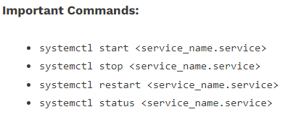

Complete this lab as follows:

Use the service –status-all command to list all active and inactive services.

List down active and inactive services in the table below. Provide five (5) services for each column.

|  |  |
| --- | --- |
| **Active** | **Inactive** |
| Alsa-utils | anacron |
| apport | apparmor |
| cron | plymouth |
| cups | uuidd |
| dbus | whoopsie |

SS:

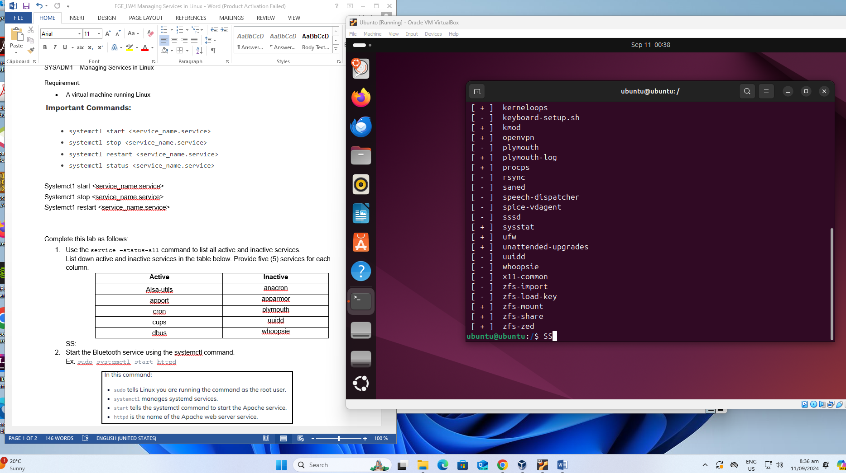

Start the Bluetooth service using the systemctl command.

Ex. sudo systemctl start httpd



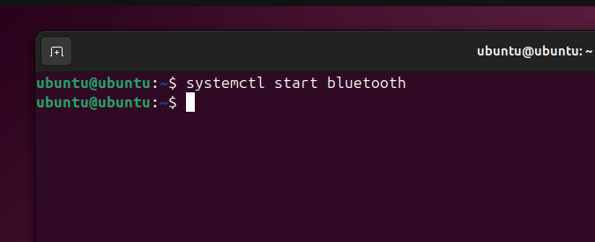

Check the status of the Bluetooth service. What is its status?

The Bluetooth service was skipped because of an unmet condition

SS: 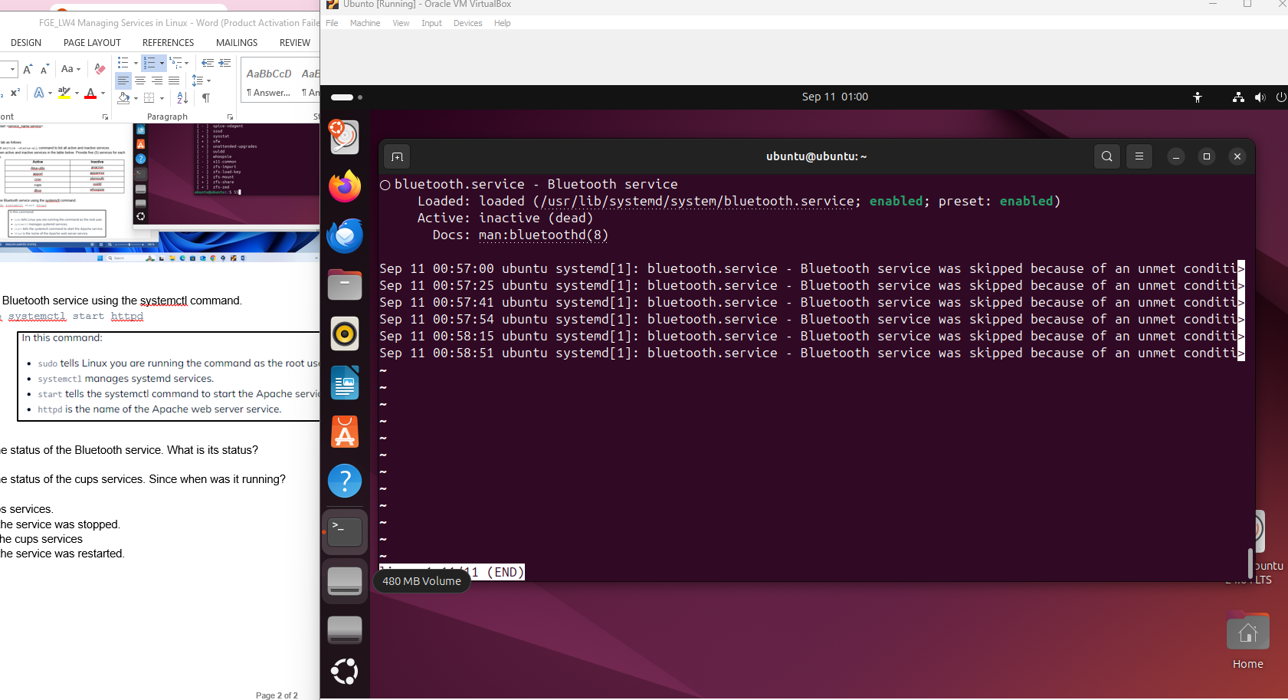

Check the status of the cups services. Since when was it running?

it was active running since wed 2024-09-11 00:53:50 UTC ; 9 min ago

SS:

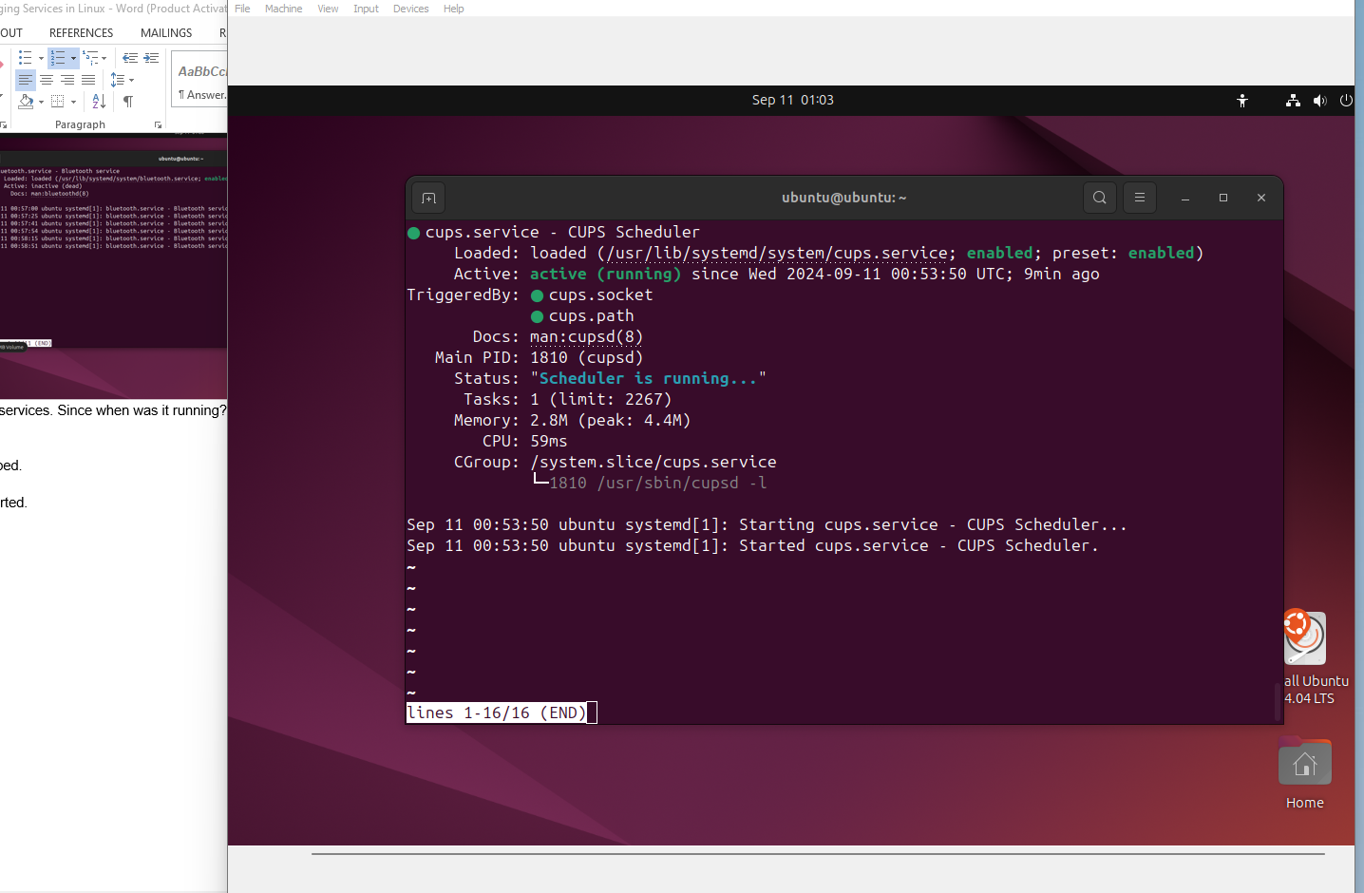

Stop cups services.

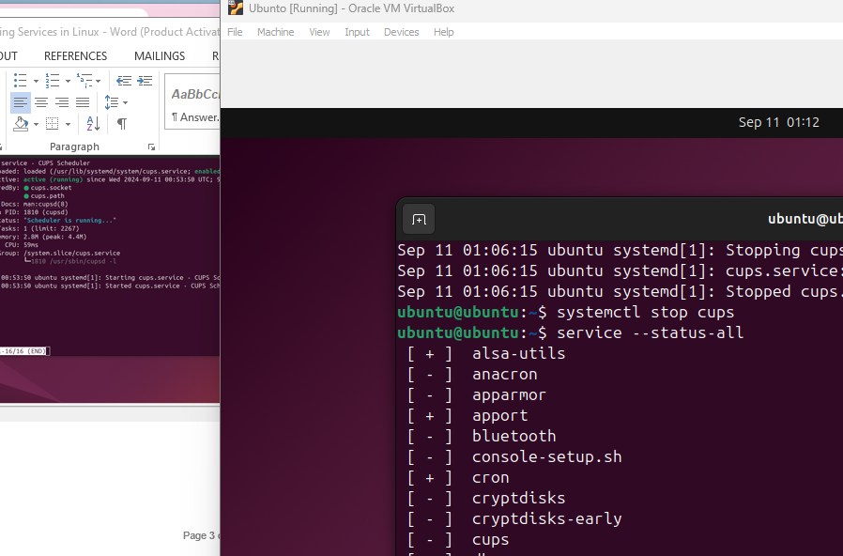

Verify if the service was stopped. 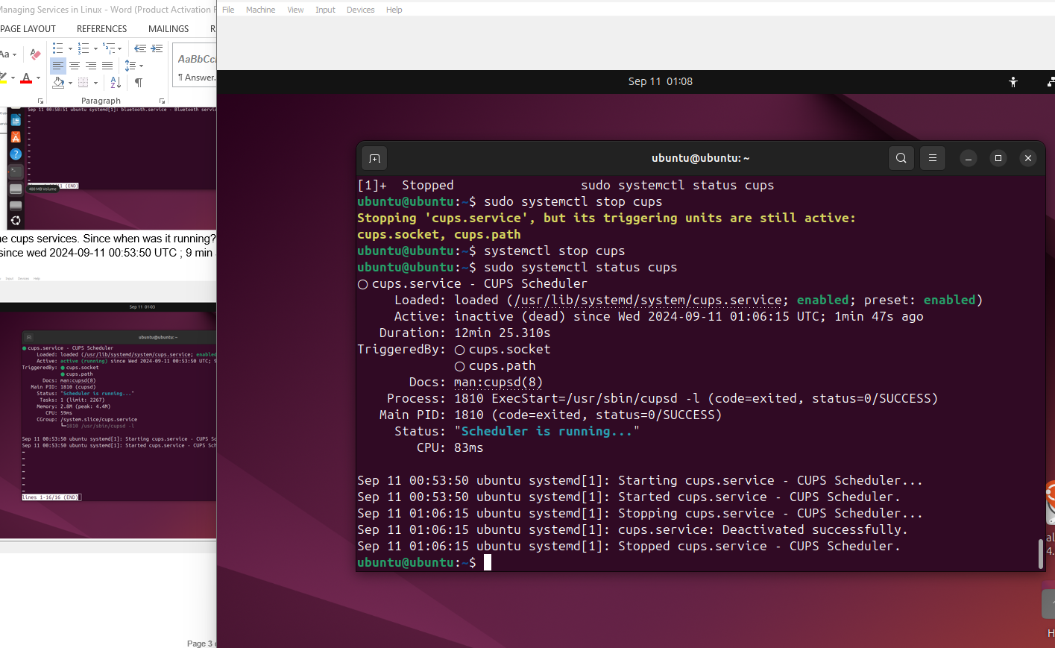

Restart the cups services

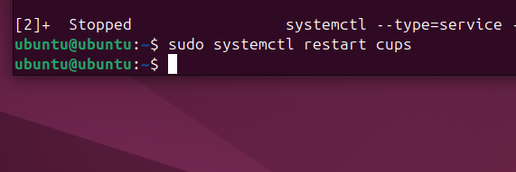

Verify if the service was restarted.

